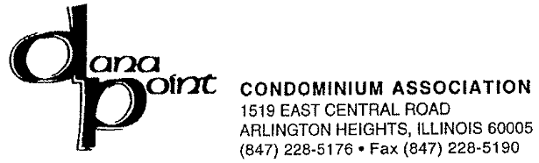

July 31, 2013
TO: Bill Volpe – Parkvue Realty Corporation
1010 N. Hooker Street – Suite 204
Chicago, IL 60642
Via Facsimilie – 312 873-4519

Receipt for Building keys for 1615 E. Central Road, Unit 112B, Arlington Heights, IL 60004
$50.00 – Check # 3326 from Parkvue Realty Corporation

Signed,

Lisette Ray – Lieberman Management Services
as agent for Dana Point Condominium Association

